Lab 5 – Discrete probability distributions
In lecture, we saw that certain kinds of experiments could be modelled by special distributions. We will now see how to model experiments described by those distributions and compute their associated probabilities in R.
To submit: answers to all numbered questions. When the question asks you to write code or create graphs, submit the code and/or graphs as part of your answer. Also copy/paste the contents of your entire R script to the end of your Word document.

Example 1: Binomial probabilities
We can calculate binomial probabilities in R using the dbinom function. The dbinom function is one of several in a family of functions involving binomial probabilities. Here is what the Help file tells us about these functions:

Usage
dbinom(x, size, prob, log = FALSE)
pbinom(q, size, prob, lower.tail = TRUE, log.p = FALSE)
qbinom(p, size, prob, lower.tail = TRUE, log.p = FALSE)
rbinom(n, size, prob)

Arguments
x, q | vector of quantiles.
p | vector of probabilities.
n | number of observations. If length(n) > 1, the length is taken to be the number required.
size | number of trials (zero or more).
prob | probability of success on each trial.
log, log.p | logical; if TRUE, probabilities p are given as log(p).
lower.tail | logical; if TRUE (default), probabilities are P[X ≤ x], otherwise, P[X > x].

If we wish to simulate rolling ten dice and finding the probability of obtaining one 3, x would equal 1, size would equal 10, and prob would equal 1/6.
> dbinom(1, 10, 1/6)
[1] 0.3230112
This tells us that the probability of obtaining a single 3 when we roll ten dice is 0.3230112. Does this agree with the formula from class? (Take a minute to check – this is good practice for your next quiz.)
Notice that in the help file, we could also have entered a vector of quantiles instead of just a single value for x. If we enter the vector c(0:10), then we will obtain a table that gives the probabilities of obtaining x heads, for x=0,1,2,…10.
If we set
> options(digits=3)
then we obtain the following probability distribution for the number of 3’s obtained when ten fair dice are rolled.
> dbinom(c(0:10), 10, 1/6)
[1] 1.62e-01 3.23e-01 2.91e-01 1.55e-01 5.43e-02 1.30e-02 2.17e-03 2.48e-04 1.86e-05 8.27e-07 1.65e-08
Or in a nicer format:
> cbind(dbinom(c(0:10), 10, 1/6))
[,1]
[1,] 1.62e-01
[2,] 3.23e-01
[3,] 2.91e-01
[4,] 1.55e-01
[5,] 5.43e-02
[6,] 1.30e-02
[7,] 2.17e-03
[8,] 2.48e-04
[9,] 1.86e-05
[10,] 8.27e-07
[11,] 1.65e-08
(Notice that the rows are indexed from 1 to 11, rather than the more useful indexing of 0 to 10. We can stick in a column that gives us the actual values of x, which run from 0 to 10:)
> cbind(c(0:10), dbinom(c(0:10), 10, 1/6))
[,1] [,2]
[1,] 0 1.62e-01
[2,] 1 3.23e-01
[3,] 2 2.91e-01
[4,] 3 1.55e-01
[5,] 4 5.43e-02
[6,] 5 1.30e-02
[7,] 6 2.17e-03
[8,] 7 2.48e-04
[9,] 8 1.86e-05
[10,] 9 8.27e-07
[11,] 10 1.65e-08

This tells us that, eg, the probability of getting two 3’s when we roll ten dice is 0.291.
And, of course, we can create a probability histogram for this results using the barplot() command. Note that we need to use the names.arg argument to get labels for each of the bars:
> barplot(dbinom(c(0:10), 10, 1/6), names.arg =c(0:10), ylab="Probabilities", main="Probability histogram for numbers of 3’s in 10 die rolls")
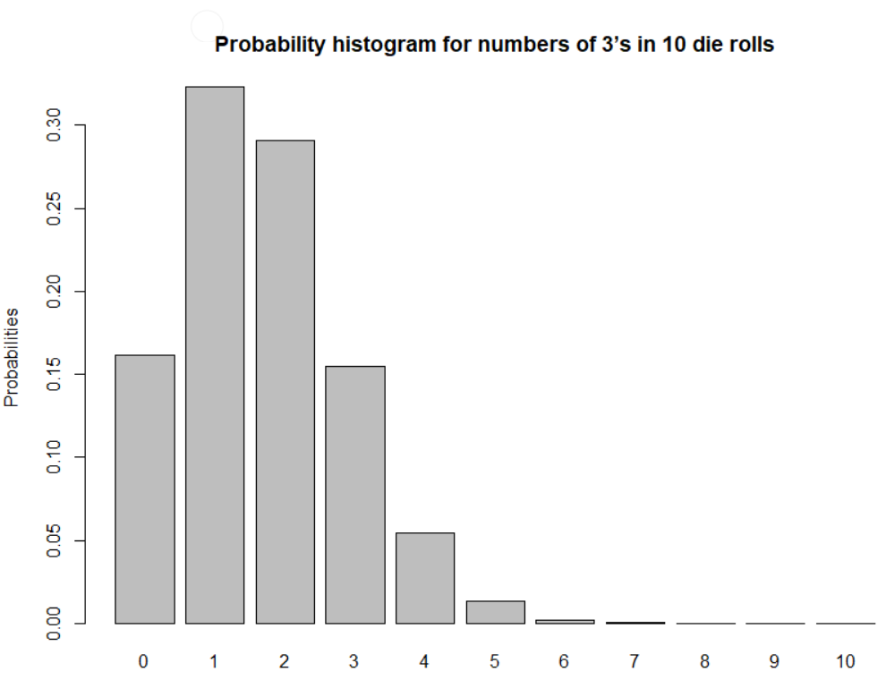
The pbinom() function allows us to compute cumulative probabilities. The following command will find the probability of obtaining two or fewer three’s when rolling a fair die ten times:
> pbinom(2,10,1/6)
[1] 0.7752268
This is particularly useful when we have binomial experiments with very large numbers of trials. questions which would be almost impossible to answer by hand. Example: We toss a fair coin 200 times. What is the probability of getting 90 heads or fewer? To do this by hand we would need to add the probability of getting 0 head + probability of getting 1 head + … + probability of getting 90 heads. Each of these would use the formula for the Binomial distribution. This would be really long. R allows us to find this value with just one command:
> pbinom(90,200,1/2)
[1] 0.08948202

- During one stage in the manufacture of integrated circuits, a coating must be applied. Suppose that it is known that one third of chips do not receive a thick enough coating. 300 chips are randomly selected for testing. Give the commands, along with your output, to compute the following probabilities (answers are in brackets):
  - Exactly 100 do not receive a thick enough coating (ans: 0.04881. Note: you can check this one on your calculator using the formulas from lecture)
  - 100 or fewer do not receive a thick enough coating (ans: 0.5271)
  - Fewer than 100 do not receive a thick enough coating (ans: 0.4783)
  - At least 110 do not receive a thick enough coating (ans: 0.1228)
  - Between 90 and 110 (inclusive) do not receive a thick enough coating (ans: 0.8017)
R also allows us to generate random numbers that follow binomial (and other kinds of) distributions. For example, if we wish to simulate rolling a die 10 times and counting the number of 3’s, we can model this by generating random numbers that follow a binomial distribution with n=10 and p=1/6. (We consider a 3 to be a success.)
> rbinom(1, 10, 1/6)
[1] 2

This result tells us that when we simulated rolling ten dice, we had two successes – ie, two of the dice came up as 3’s.
We could obtain a good approximation of the distribution of 3’s by running this simulation many times, say 10000. (R is a bit confusing here – we would assign the value 10 to the parameter size, and the number of simulations (in this case 10000) would be n).
We don’t want R to display 10000 values in the console, so here is a command that simulates rolling a set of 10 dice 20 times, and returns the number of 3’s for each of those 20 experiments:
> numthrees=rbinom(20, 10, 1/6)
> numthrees
[1] 0 0 0 1 0 2 4 1 0 2 2 1 3 2 1 1 1 4 1 1

It looks like most of the time, when we roll ten dice, we get zero, one, or two 3’s. (Does this seem right?) Less commonly, we get three or four 3’s.
We can organize those results in a table:
> table(numthrees)
numthrees
0 1 2 3 4
5 8 4 1 2
Alternatively, we can display the table vertically:
> cbind(table(numthrees))
[,1]
0 5
1 8
2 4
3 1
4 2

We can also convert the number of 3’s to relative frequencies by dividing the right hand side of our table by the total number of die rolls (in this case 20):
> table(numthrees)/20
numthrees
0 1 2 3 4
  - 0.40 0.20 0.05 0.10

- Approximate the probability distribution for the number of 3’s obtained when rolling 10 dice with relative frequency distributions in two different ways, as follows:
  - By writing a function that simulates rolling m dice n times, using the sample() function and techniques from Lab 4. Your function should output a table giving the relative frequencies of obtaining different numbers of 3’s, as well as create a bar plot. Run your function for m=10, n=10000 and provide a table and a bar plot.
  - By writing a function that simulates rolling m dice n times, using the rbinom() function. As before, your function should output a table giving the relative frequencies, as well as a bar plot. Run your function for m=10, n=10000 and provide a table and a bar plot.
Note: both of your bar plots should look very similar to the exact probability distribution obtained
with the dbinom() function. If yours look significantly different, there is something wrong with your code.

Example 2: hypergeometric probabilities
We saw in class that sampling without replacement can be modelled by hypergeometric distributions. R provides a family of functions involving the hypergeometric distribution, similar in syntax and usage to the family of functions we saw for binomial distributions. The dhyper() function computes hypergeometric probabilities directly. We can look it up, along with the other functions in the family, in the help file. Note that the help file gives a very concrete example involving drawing balls from an urn, but it can be generalized to any situation that involves sampling without replacement. (We can ignore the log argument.)

The Hypergeometric Distribution

Description

Density, distribution function, quantile function and random generation for the hypergeometric distribution.

Usage
dhyper(x, m, n, k, log = FALSE)
phyper(q, m, n, k, lower.tail = TRUE, log.p = FALSE)
qhyper(p, m, n, k, lower.tail = TRUE, log.p = FALSE)
rhyper(nn, m, n, k)

Arguments
x, q | vector of quantiles representing the number of white balls drawn without replacement from an urn which contains both black and white balls.
m | the number of white balls in the urn.
n | the number of black balls in the urn.
k | the number of balls drawn from the urn.
p | probability, it must be between 0 and 1.
nn | number of observations. If length(nn) > 1, the length is taken to be the number required.
log, log.p | logical; if TRUE, probabilities p are given as log(p).
lower.tail | logical; if TRUE (default), probabilities are P[X ≤ x], otherwise, P[X > x].

The dhyper() and phyper() functions are analogous to the dbinom() and pbinom() functions. For instance, we can find the probability of getting exactly two jacks when drawing ten cards from a standard 52-card deck:
> dhyper(2,4,48,10)
[1] 0.1431157
We can also find the probability of drawing two or fewer jacks when drawing ten cards without replacement from a standard 52-card deck:
> phyper(2,4,48,10)
[1] 0.9806076
- Imagine that we are drawing cards from a standard 52-card deck without replacement. Using the dhyper() function, give a table and a barplot that gives that exact probability distribution for the number of aces obtained when 8 cards are drawn without replacement. (You may want to compare at least one of the probabilities to the one you get by using the formula from class.) Be sure to give clear and descriptive labels for your barplot. You may want to refer to the example using dbinom() given in Lab 4. Note: there are four aces in a standard 52-card deck.

- Approximate the probability distribution for the number of aces obtained when drawing 8 cards from a standard 52-card deck using relative frequencies obtained from two different simulations, as follows:
- By writing a function that simulates drawing m cards n times, using the sample() function and techniques from Lab 5. (You can adapt one of the functions you wrote from Lab 5.) Your function should output a table giving the relative frequencies, as well as a bar plot. Run your function for m=8, n=10000 and provide the table and a bar plot.
- By writing a function that simulates drawing m cards n times, using the rhyper() function. As before, your function should output a table giving the relative frequencies, as well as a bar plot. Run your function for m=8, n=10000 and provide a table and a bar plot.
The tables and bar plot from parts (a) and (b) should be very similar to the one obtained with the dhyper() function.

- During one stage in the manufacture of integrated circuits, a coating must be applied. Suppose that in a batch of 999 chips, 333 did not receive a thick enough coating. 300 of the 999 chips are randomly selected for testing. Give the commands, along with your output, to compute the following probabilities (answers are in brackets):
  - Exactly 100 do not receive a thick enough coating (ans: 0.05835. Note: you can check this one on your calculator using the formulas from lecture)
  - 100 or fewer do not receive a thick enough coating (ans: 0.5305)
  - Fewer than 100 do not receive a thick enough coating (ans: 0.4721)
  - At least 110 do not receive a thick enough coating (ans: 0.08254)
  - Between 90 and 110 (inclusive) do not receive a thick enough coating (ans: 0.8759)

Example 3: geometric probabilities
From class, we saw that we can model trials that we repeat until we obtain a success with the geometric distribution. The dgeom() function returns the probability that an experiment with probability prob of success will require x trials before obtaining a success. There are a few related functions, and their syntax should be pretty familiar to you by now!

The Geometric Distribution

Description
Density, distribution function, quantile function and random generation for the geometric distribution with parameter prob.

Usage
dgeom(x, prob, log = FALSE)
pgeom(q, prob, lower.tail = TRUE, log.p = FALSE)
qgeom(p, prob, lower.tail = TRUE, log.p = FALSE)
rgeom(n, prob)

Arguments
x, q | vector of quantiles representing the number of failures in a sequence of Bernoulli trials before success occurs.
p | vector of probabilities.
n | number of observations. If length(n) > 1, the length is taken to be the number required.
prob | probability of success in each trial. 0 < prob <= 1.
log, log.p | logical; if TRUE, probabilities p are given as log(p).
lower.tail | logical; if TRUE (default), probabilities are P[X ≤ x], otherwise, P[X > x].
One major difference between the geometric distribution and the binomial and hypergeometric distributions is that there is no upper bound on the number of nonzero probabilities. For example, if you roll a die 10 times, the maximum number of 3’s you can get is 10. If you draw 8 cards without replacement, you will get at most 4 aces. But if you purchase a lottery ticket every week until you get a winning one – an experiment modelled by the geometric distribution – you may theoretically be purchasing lottery tickets forever! However the probability of having to purchase a “very large” number of lottery tickets is very small and can be considered to be zero for all practical purposes. So in our case, when creating our probability tables, we will exclude the very small probabilities, because otherwise our tables will be infinite.
- A student decides to purchase lottery tickets until she wins a prize. Suppose the probability of winning a prize is 1/5. (Most of these prizes are quite small!). Use the dgeom() function to find the exact probability distribution for the number of tickets the student will buy before getting a winner. (You may want to compare at least one of the probabilities to the one you get by using the formula from class.) You can exclude all probabilities less than 0.0001. (You may have to experiment a bit to figure out what the cutoff for your vector of quantiles is.) Give the probability distribution as both a table and a bar plot.

- Approximate the probability distribution for the number of lottery tickets the student must buy before obtaining a winner in two ways:
- By writing a function that uses the sample() function to simulate n students who each purchase lottery tickets until a winner is obtained. Your function should output a table giving the relative frequencies, as well as a bar plot. Run your function for n=10000 and provide a table as well as a bar plot with clear and descriptive labels.
- By writing a function that simulates n people purchasing lottery tickets until getting a winner, using the rgeom() function. As before, your function should output a table giving the relative frequencies, as well as a bar plot. Run your function for n=10000 and provide a table and a bar plot.
The results of both of your simulations should be very similar to the results obtained with the dgeom() function.
The pgeom() function computes cumulative probabilities. For example, we can compute the probability of having to purchase 8 or fewer tickets in order to get a winner:
> pgeom(7,1/5)
[1] 0.8322278
- In a “torture test”, a light switch is turned on and off until it fails. The probability is 0.001 that it will fail any time it is turned on or off. Find the probability that:
  - The switch will fail before it has been turned on and off 500 times? (ans: 0.3930)
  - The switch will not fail until it has been turned on and off at least 1200 times? (ans: 0.3013)
  - The switch will fail when it has been turned on and off between 1000 and 2000 times (inclusive)? (ans: 0.2329)

